**ASSIGNMENT 10.6**

1.Write a pig script to find the minimum temperature observed in a given weather station in a particular year.

2. Write a pig script to find the maximum temperature observed in a given weather station in a particular year.

3. Write a pig script to find the number of readings given by each weather station according to the dataset. You can download the dataset from the below link Temperature_Data Data Definition:

Column 1: Weather Station

Column 2: Date(year/Month/Day)

Column 3: Observation Type

Column 4: Temperature

ANS 1) INPUT

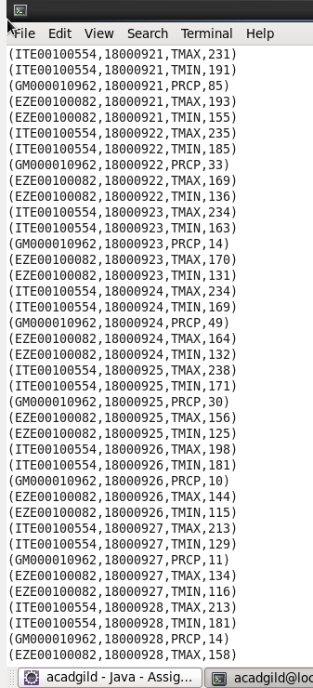

**IN THE INPUT FILE TEMP.TXT THERE IS A EMPTY LINE ALSO PRESENT,SO OUTPUT WILL COME ACCORDINGLY.IF WE DELETE THAT EMPTY LINE WE CAN RECTIFY IT**

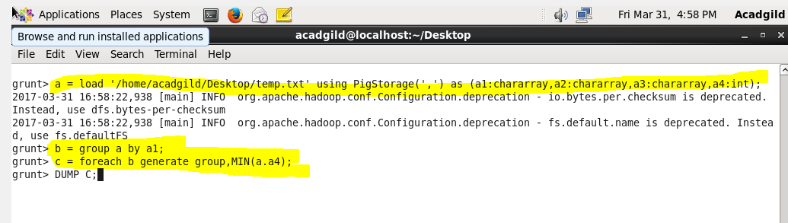

**FIRST WE WILL GROUP BY STATION**

**SECOND USING FOREACH LOOP GENERATE MINIMUM TEMPERATURE**

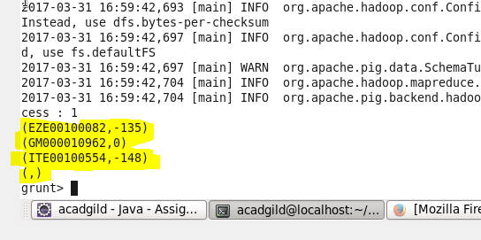

**OUTPUT**

**2)**

**MAXIMUM TEMP**

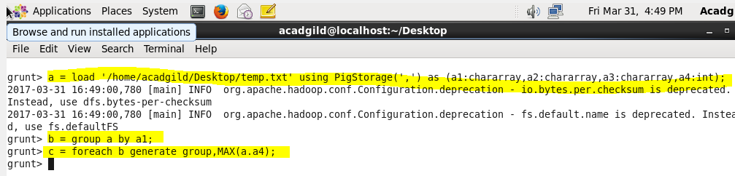

**SAME AS MIN BUT JUST USE THE MAX FUNCTION**

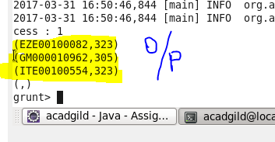

**MAX TEMP FOR EACH WEATHER STATION**

**3)**

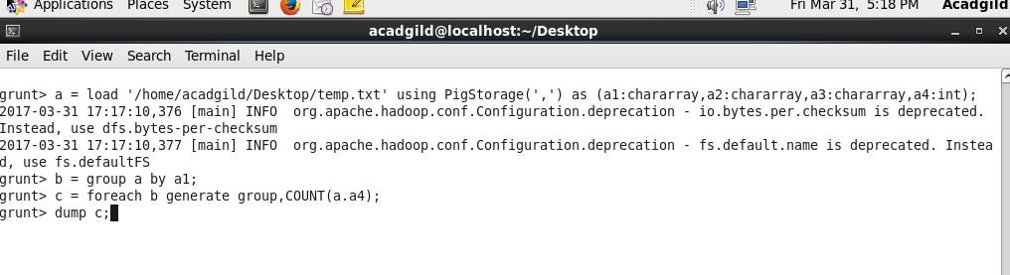

**GROUP BY STATION AND AND THEN USING COUNT FUNCTION COUNT TEMP READING FOR EACH STATION**

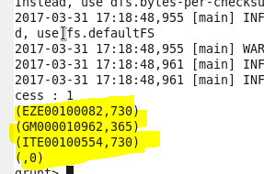

**OUTPUT TOTAL READING FOR EACH STATION**